Basic Commands in Linux

- Commands are actually files containing programs, often written in C. How will you find out in which directory does the file corresponding to the man command resides?

Answer:

the command "type" is used to find the type of command.
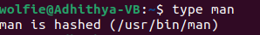

2) How will you find out what is the use of the ps command.

Answer:

the command "man" is used to find the use of any command.
